**Roll No:-32**

**Name:- Dhake Nikhil Manohar**

**Practical No:-03**

**Practical Name:- use git to add to add that fileto the repository. Use git commit to commit your change**

Nikhil@Dknik MINGW64 ~

$ git version

git version 2.36.1.windows.1

Nikhil@Dknik MINGW64 ~ (master)

$ git clone https://github.com/dkniik/Imr.git

Cloning into 'Imr'...

remote: Enumerating objects: 3, done.

remote: Counting objects: 100% (3/3), done.

remote: Total 3 (delta 0), reused 0 (delta 0), pack-reused 0

Receiving objects: 100% (3/3), done.

Nikhil@Dknik MINGW64 /c/nikhild (master)

$ cd nikhild

Nikhil@Dknik MINGW64 /c/nikhild (main)

$

Nikhil@Dknik MINGW64 ~ (master)

$ git --help

usage: git [--version] [--help] [-C <path>] [-c <name>=<value>]

[--exec-path[=<path>]] [--html-path] [--man-path] [--info-path]

[-p | --paginate | -P | --no-pager] [--no-replace-objects] [--bare]

[--git-dir=<path>] [--work-tree=<path>] [--namespace=<name>]

[--super-prefix=<path>] [--config-env=<name>=<envvar>]

<command> [<args>]

These are common Git commands used in various situations:

start a working area (see also: git help tutorial)

clone Clone a repository into a new directory

init Create an empty Git repository or reinitialize an existing one

work on the current change (see also: git help everyday)

add Add file contents to the index

mv Move or rename a file, a directory, or a symlink

restore Restore working tree files

rm Remove files from the working tree and from the index

examine the history and state (see also: git help revisions)

bisect Use binary search to find the commit that introduced a bug

diff Show changes between commits, commit and working tree, etc

grep Print lines matching a pattern

log Show commit logs

show Show various types of objects

status Show the working tree status

grow, mark and tweak your common history

branch List, create, or delete branches

commit Record changes to the repository

merge Join two or more development histories together

rebase Reapply commits on top of another base tip

reset Reset current HEAD to the specified state

switch Switch branches

tag Create, list, delete or verify a tag object signed with GPG

collaborate (see also: git help workflows)

fetch Download objects and refs from another repository

pull Fetch from and integrate with another repository or a local branch

push Update remote refs along with associated objects

'git help -a' and 'git help -g' list available subcommands and some

concept guides. See 'git help <command>' or 'git help <concept>'

to read about a specific subcommand or concept.

See 'git help git' for an overview of the system.

Nikhil@Dknik MINGW64 /c/nikhild (main)

$ git init

Reinitialized existing Git repository in C:/nikhild/.git/

Nikhil@Dknik MINGW64 /c/nikhild (main)

$ touch demo.txt

Nikhil@Dknik MINGW64 /c/nikhild (main)

$ git add demo.txt

Nikhil@Dknik MINGW64 /c/nikhild (main)

$ git commit -m "hey"

[main 70835c3] hey

1 file changed, 2 insertions(+)

create mode 100644 nikhil.txt

Nikhil@Dknik MINGW64 /c/nikhild (main)

$ git config --global user.name "dkniik"Nikhil@Dknik MINGW64 /c/nikhild (main)

$ git config --global user.email “[nikhiildhake@gmail.com](mailto:nikhiildhake@gmail.com)”

**//Before Add and Commit**

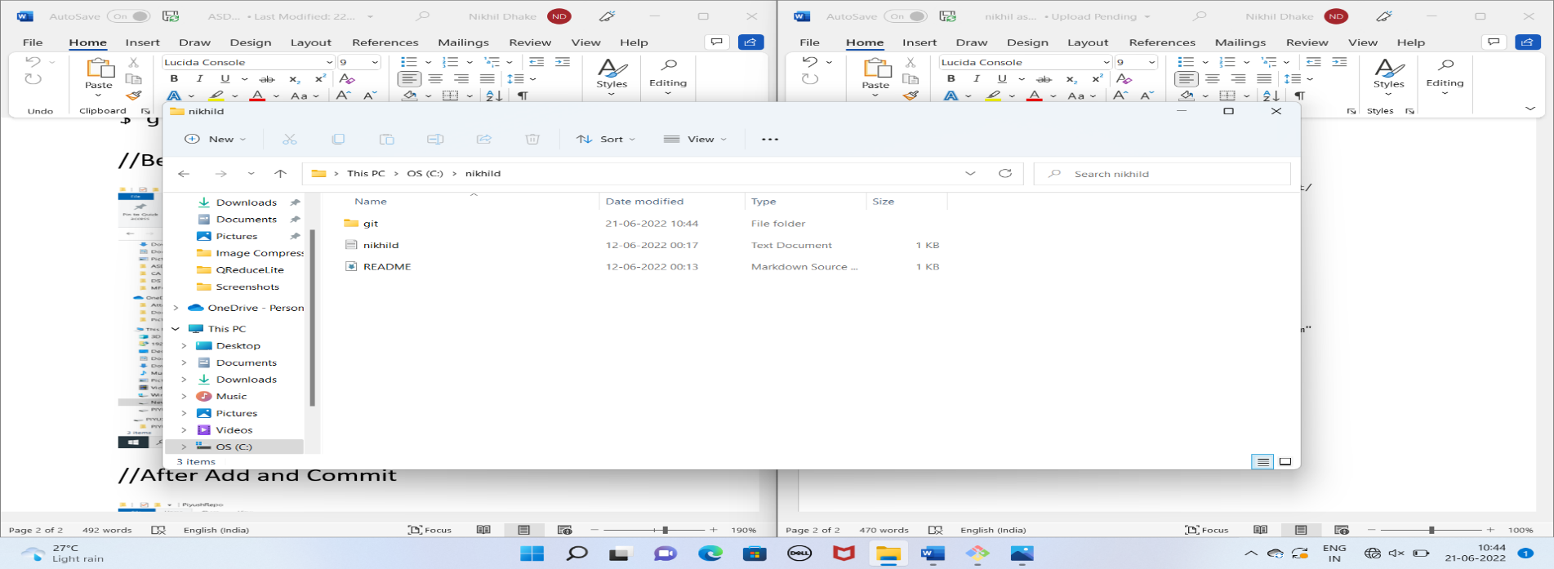

**//After Add and Commit**

